
Department of Computer Science

Lab Manual

of

MACHINE LEARNING

MCA521-4

Class Name: IV MCA B

Master of Computer Application

2026

Prepared by: ( Kunnal ) Verified by:
Dr. Rupali Sunil Wagh
Dr. Helen K Joy
Dr. Shivangi Singh

Department Overview
Department of Computer Science of CHRIST (Deemed to be University) strives to shape outstanding computer professionals with ethical and human values to reshape nation’s destiny. The training imparted aims to prepare young minds for the challenging opportunities in the IT industry with a global awareness rooted in the Indian soil, nourished and supported by experts in the field.

Vision
The Department of Computer Science endeavours to imbibe the vision of the University “Excellence and Service”. The department is committed to this philosophy which pervades every aspect and functioning of the department.

Mission
“To develop IT professionals with ethical and human values”. To accomplish our mission, the department encourages students to apply their acquired knowledge and skills towards professional achievements in their career. The department also moulds the students to be socially responsible and ethically sound.

Introduction to the Programme
Master of Computer Applications (MCA) is a post-graduate programme of CHRIST (Deemed to be University) and approved by the All India Council of Technical Education (AICTE). It is a two-year programme spread over six trimesters to bridge the chasm between computer studies and applications, bringing within reach of enthusiastic youngsters an excellent group of experienced and dedicated staff and experts, and an enviable infrastructure. MCA at CHRIST (Deemed to be University) strives to shape outstanding computer professionals with ethical and human values to reshape the nation’s destiny. The training programme aims to prepare young minds for challenging opportunities in the IT industry with a global awareness rooted in the Indian soil, nourished and supported by experts in the field. The Department is committed to the motto “Excellence and Service,” and this philosophy pervades every aspect of its functioning.

Programme Objective
This programme is conceptualised and designed based on the strong commitment of the
department to provide better quality education to the students. The principal objectives of this
course are to:
● Heighten technological awareness
● Train future industry specialists
● Encourage effective software development
● Provide research training
● Involve students in innovative research
● Produce graduates with a two-year professional education in Computer Science with
technical, professional, and communications skills.

Ethics and Human Values
1. Only proprietary or open-source software would be used for academic teaching and
learning purposes.
2. Copying of programs from the internet, friends or from other sources is strictly
discouraged since it impairs development of programming skills.
3. Unique Practical (Domain based) exercises ensure that the students don’t get involved in
code plagiarism.
4. Projects undertaken by students during the course are done in teams to improve
collaborative work and synergy between team members.
5. Projects involve modularization which initiates students to take individual responsibility
for common goals.
6. Passion for excellence is promoted among the students, be it in software development or
project documentation.
7. Giving due credit to sources during the seminar and research assignment is promoted
among the students
8. The course and its design enforce the practice of good referencing technique to improve
the sense of integrity.
9. Courses involving group discussions and debates on ethical practices and human values
are designed to sensitize the students in dealing with customers and members within the
Organization.

Programme Outcomes:
P01: Foundation Knowledge: Apply knowledge of mathematics, programming logic, and
coding fundamentals for solution architecture and problem-solving.
P02: Problem Analysis: Identify, review, formulate, and analyse problems primarily focussing on customer requirements using critical thinking frameworks.
P03: Development of Solutions: Design, develop and investigate problems with as an
innovative approach for solutions incorporating ESG/SDG goals.
PO4: Modern Tool Usage: Select, adapt, and apply modern computational tools such as the
development of algorithms with an understanding of the limitations including human biases.
P05: Individual and Teamwork: Function and communicate effectively as an individual or a
team leader in diverse and multidisciplinary groups. Use methodologies such as agile.
P06: Project Management and Finance: Use the principles of project management such as
scheduling, and work breakdown structure and be conversant with the principles of Finance for profitable project management.
P07: Ethics: Commit to professional ethics in managing software projects with financial aspects.
Learn to use new technologies for cyber security and insulate customers from malware
P08: Life-long learning: Change management skills and the ability to learn, keep up with
contemporary technologies and ways of working.

Programme Educational Objectives(PEO’s)
PEO1: Develop innovative and effective software solutions through research that addresses
real-world challenges, grounded in a commitment to continuous learning and adaptability.
PEO2: Advance the knowledge and practices in the field of computer applications through
lifelong learning and rigorous research, supporting professional growth and academic excellence.
PEO3: Exhibit ethical leadership, social responsibility to contribute and enhance community
well-being by innovating solutions.
MCA521-4 – MACHINE LEARNING
Course Name: MACHINE LEARNING Code: MCA521-4
Total Hours: 75
L + P + T: 3 + 4 + 0
Max Marks: 100
Credits: 4
Course Type: Core Course
Course Category: Theo&Prac
Course Description
Machine Learning is a key area in computer applications that focuses on building models capable of making predictions or informed decisions based on data. A strong understanding of machine learning enables students to analyze and interpret complex datasets, develop predictive models, and extract meaningful insights. This course covers a wide range of machine learning concepts and techniques, including supervised and unsupervised learning. It provides a solid theoretical foundation while emphasizing practical, hands-on experience with algorithms and real-world data. The course equips students with the knowledge and skills required to apply machine learning techniques across various domains using modern tools and methodologies.
Course Objectives
This course enables students to understand the fundamental concepts of Machine Learning, including its core principles, terminology, and methodologies. Students will learn to differentiate between various types of learning algorithms such as supervised, unsupervised, and reinforcement learning, and recognize their appropriate applications.
Course Outcomes
After successful completion of the course, students will be able to:
● Explain the fundamental principles and scope of Machine Learning
● Implement modelling practices in machine learning for better generalisation
● Interpret predictive modelling results and performance of supervised machine learning techniques
● Assess the outcomes and effects of unsupervised machine learning processes
● Deploy robust machine learning models for interdisciplinary applications

Unit-1: INTRODUCTION TO MACHINE LEARNING Teaching Hours: 15 Hours
Introduction to AI – Knowledge Representation – Data – Representation of Data, Data Processing, Data Storage, Data Processing, Types of Data – Exploratory Data Analysis, Visualisations and Interpretation, Outliers
Machine Learning: Definition, Objectives, Components, Features, Applications – Traditional Programming v/s Machine Learning, Types of Machine Learning – Predictive Models, Statistical Inferences – Applications of Machine Learning
Challenges in ML: Insufficient Quantity of Data, Non-representative and Poor-Quality Data, Irrelevant Features, Estimation Estimation, Reducing Human Biases in Model Building, Ethical Use of Technology
Lab Exercises:
1. Data Preprocessing and visualisation
2. Data exploration and inferences

Unit-2: PROCESSES IN MACHINE LEARNING Teaching Hours: 15 Hours
Data Preparation and Model Selection: Effect of Data Preparation: Encoding, Nominal and Ordinal Representation, Feature Transformation and Feature Engineering, Generalisation, Normalisation, Sampling, Using Saved Weights, Model Selection Strategies: Overfitting, Underfitting, Bias-Variance Trade-off, Testing and Validation: Performance measures - Confusion matrix, Precision-Recall Trade off, F1 Score, ROC Curve, AUC, Error Analysis, Model Parameters, Hyperparameters, Hyperparameter Tuning, Cross Validation, Decision Functions: Introduction to Supervised Machine Learning Methods, Decision Functions, Decision Thresholds, Distance Measures, Hyperplanes, Regression & Classification Problems, Loss and Cost Functions, Linear Regression using OLS, Multi-class vs Multi-label, KNN Classification
Lab Exercises:
3. Saving weights of a generalised model.
4. Regression and Classification Evaluation Metrics: Illustration through Linear Regression and KNN Classification

Unit-3: SUPERVISED LEARNING ALGORITHMS Teaching Hours: 15 Hours
Learning through Optimisation: Gradient Descent, Linear Regression, Logistic Regression Computational Learning: Decision Trees, Naive-bayes classification, Support Vector Machines, Ensemble Learners: Learning, Voting, Bagging, Stacking, Boosting, Random Forests, GridSearchCV
Lab Exercises:

5. Regression through Gradient Descent
6. Comparison of Different Classifiers
7. Illustration of Ensemble Learning Methods

Unit-4: UNSUPERVISED LEARNING AND DIMENSIONALITY REDUCTION Teaching Hours: 15 Hours
Introduction: Types of Unsupervised Learning, Challenges in Unsupervised Learning, Concept of Cost Functions in Unsupervised Learning, Clustering Methods: Distance based, Centroid Based, Elbow method to find Optimal Number of Clusters, Silhouette Method, K-Means Clustering, Hierarchical Clustering: Agglomerative and Bottom Up, Applying Supervised Learning after Clustering, Dimensionality Reduction Methods: Principal Component Analysis (PCA), Linear Discriminant Analysis (LDA)
Lab Exercises:
8. KMeans and Elbow Methods
9. Hierarchical Clustering and Dendrograms
10. Dimensionality Reduction
11. Image Compression using Dimensionality Reduction.

Unit-5 Teaching Hours: 15 Hours
MACHINE LEARNING IN REAL-WORLD
Emerging Techniques: Role of ML in attaining Sustainable Development Goals, Time Series Preprocessing, Blackbox Methods: Neural Networks & Deep Learning, Reinforcement Learning/QLearning, Self Supervised Learning, Quantum Machine Learning, Keras and Tensorflow for designing Multi Layer Perceptron. Case Studies: CNN, RNN, Advances in Deep Learning, Natural Language Processing, Real Time Systems, Computer Vision, Robotics, Expert Systems, Generative Networks, Large Language Models. Model Deployment: Model Deployment: Connecting Models to User Interface, Deployment of ML Models.
Lab Exercises:
12. Training a Multi-layer perceptron
13. Deploying Trained ML-models

Text and Reference Books
[1] Campesato, O. (2020). Artificial Intelligence, Machine Learning and Deep Learning. Mercury Learning and Information.
[2] Andreas C. Müller and Sarah Guido (2017), “Introduction to Machine Learning with Python A Guide For Data Scientists” O’Reilly book
[3] Ethem Alpaydin (2005), “Introduction to Machine Learning”, Prentice Hall of India
[4] Max Kuhn and Kjell Johnson (2018), “Applied Predictive Modelling”, Springer

Essential Reading
[1] Stuart Russell and Peter Norvig(2020), “Artificial Intelligence: A Modern Approach” (4th Edition), Pearson
[2] Aurelien Geron(2019), “Hands on Machine Learning with Scikit-learn, Keras and Tensorflow”, 2nd Edition, O’Reilly Books
[3] Kevin P. Murphy(2012), “Machine Learning: A Probabilistic Perspective”, MIT Press
[4] Hastie, Tibshirani, Friedman(2008), “The Elements of Statistical Learning” (2nd ed), Springer
[5] Ian Goodfellow, Aaron Courville, Yoshua Bengio (2019), “Deep Learning (Adaptive Computation And Machine Learning Series)”, MIT Press
Additional Information (Web Resources):
1. Andrew Ng, Deeplearning.ai, Machine Learning Specialisation, offered through Coursera: https://www.deeplearning.ai/courses/machine-learning-specialization/

Evaluation Pattern: CIA - 50% ESE - 50%

LIST OF PROGRAMS

MSCAIML
Sl.no | Title of lab Experiment | Page number | RBT | CO
1 | Lab1 Data preprocessing and visualisation | 8 to 28 | L3 | CO1,3
2 | Lab2 Data exploration and inferences | 29 to 48 | L3 | CO2,3
3 |  |  | L3 | CO3
4 |  |  | L3 | CO3
5 |  |  | L3 | CO3
6 |  |  | L3 | CO3,4
7 |  |  | L4 | CO3
8 |  |  | L3 | CO3
9 |  |  | L3 | CO4
10 |  |  | L5 | CO4

Evaluation Rubrics:
Evaluation Rubrics for each program would be

Submission Guidelines:
- Make a copy of the lab manual template with your <name_reg:no_subject name >,

- Copy the given question and the answer (lab code) with results, followed by the conclusion of that lab. Title the lab as lab number.
- Keep updating your lab manual and show the lab manual of that particular lab for evaluation.
- Create a Git Repository in your profile <ML lab-reg no> . Follow a different branch for each lab <Lab 1, Lab 2…>, and push the code to Git. The link should be provided in Google Classroom along with the PDF of the lab manual.
- Upload the PDF to Google Classroom before the deadline.

Lab 1

Lab Exercise I:

Aim
- To investigate whether worsening air quality across Indian states is linked to declining agricultural output by independently choosing, applying, and justifying appropriate data analysis and visualisation techniques on raw, messy, real-world datasets.

Evaluation Rubrics

Submission Guidelines
- Make a copy of the lab manual template with your <name_reg:no_subject name>
- Copy the given question and the answer (lab code) with results, followed by the conclusion of that lab. Title the lab as Lab 1.
- Keep updating your lab manual and show the lab manual of that particular lab for evaluation.
- Create a Git repository in your profile <ML lab-reg no>. Follow a different branch for each lab <Lab 1, Lab 2 …> and push the code to Git.
- Provide the Git link in Google Classroom along with the PDF of the lab manual.
- Upload the PDF to Google Classroom before the deadline.

Code with Results

Task 1

A junior analyst hands you two CSV files and says — "I have no idea what's in these. We need to use them to build a machine learning model next week." Before any analysis can begin, you need to understand what you are working with.

Investigate both files thoroughly. Produce a structured summary that gives a complete first-impression picture of the data — its size, its contents, and where it might be problematic. Decide what information a data scientist would need before trusting this data, and make sure your summary covers all of it.

A structured data profile for each file in a markdown cell
At least one written observation about what concerns you after the inspection
Think: What does a data scientist need to know about a dataset before using it? What functions help you find that? 2 marks Completeness of profile + written concern
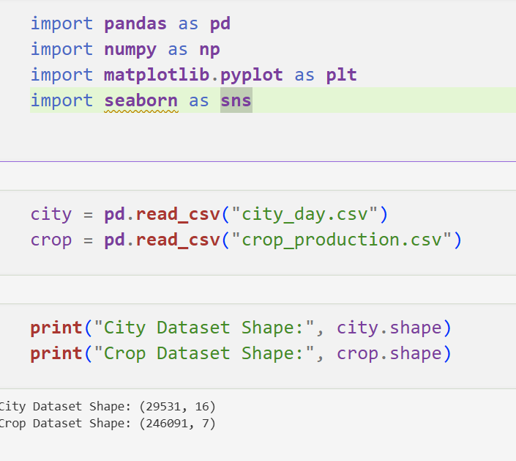
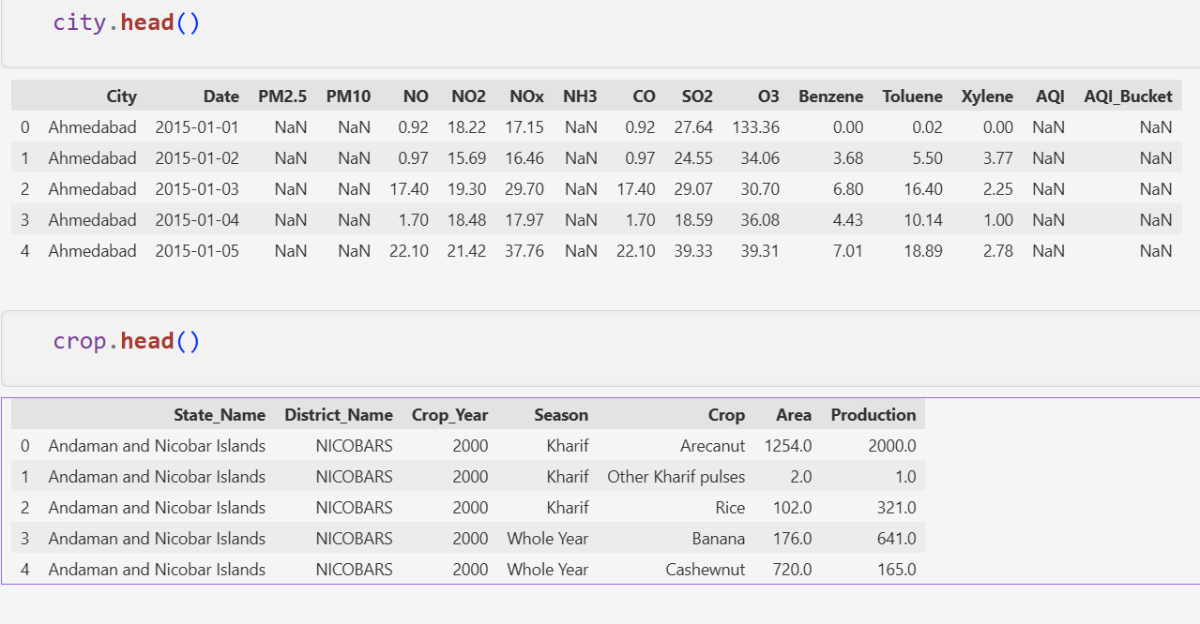
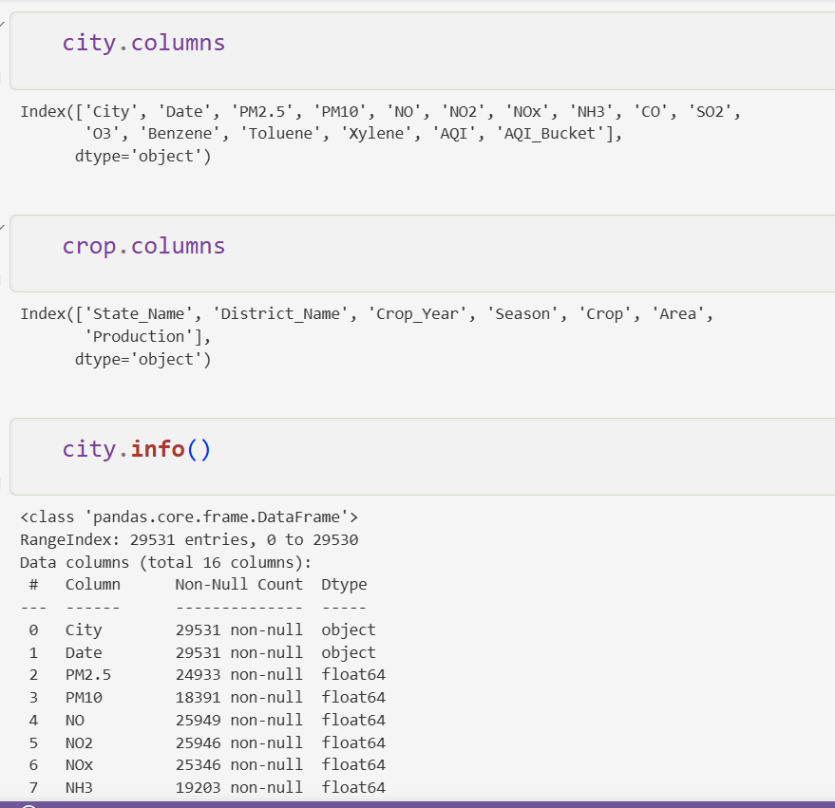
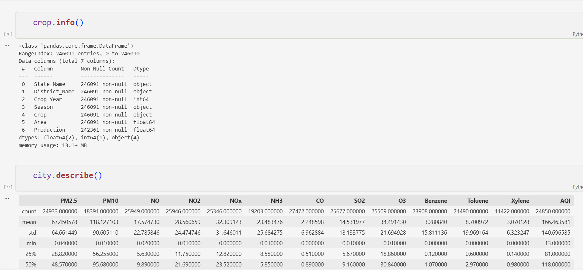
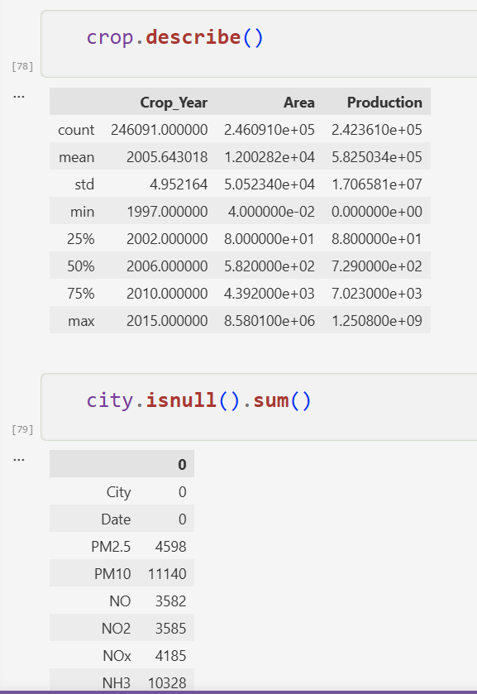
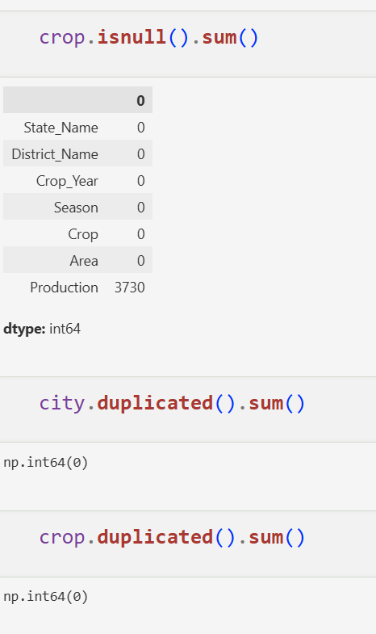
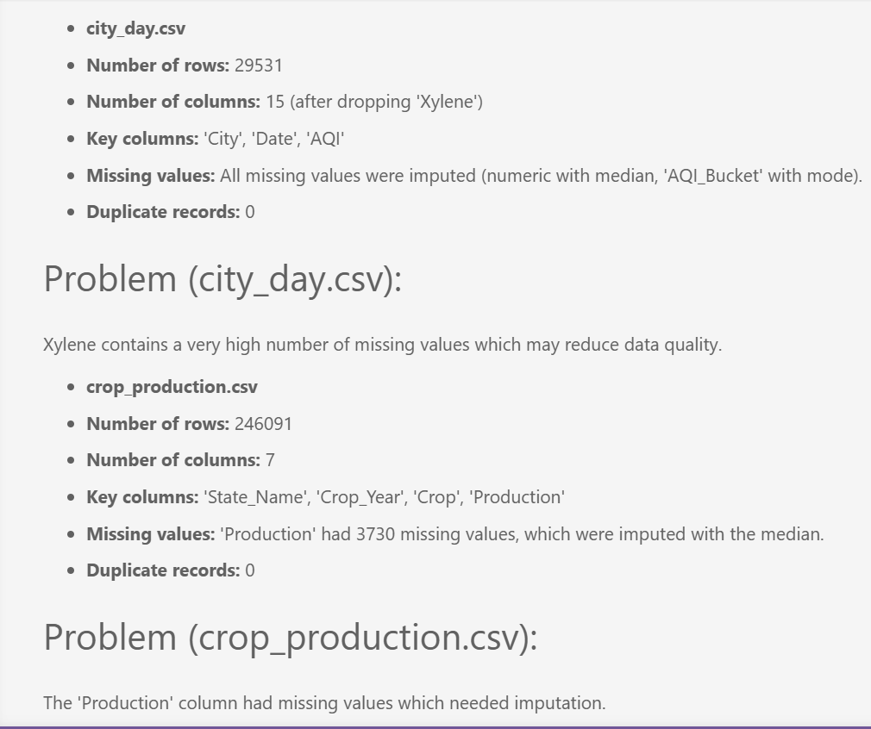

Task 2 The data has holes — and not all holes are equal

After the inspection, it is clear that several columns have missing values. A colleague suggests simply deleting all rows with any null value. Another suggests filling everything with the mean. You are not sure either approach is right.
Devise your own missing value treatment strategy. For each column with missing data, decide whether to drop it, drop affected rows, or impute — and explain why that choice is appropriate for that specific column. Apply your strategy and verify it worked.

A markdown cell that justifies each decision column by column
Before and after null counts as evidence the treatment worked

Think: Does the volume of missing data matter? Does the column type matter? What does imputing with mean vs median assume about the data? 2 marks
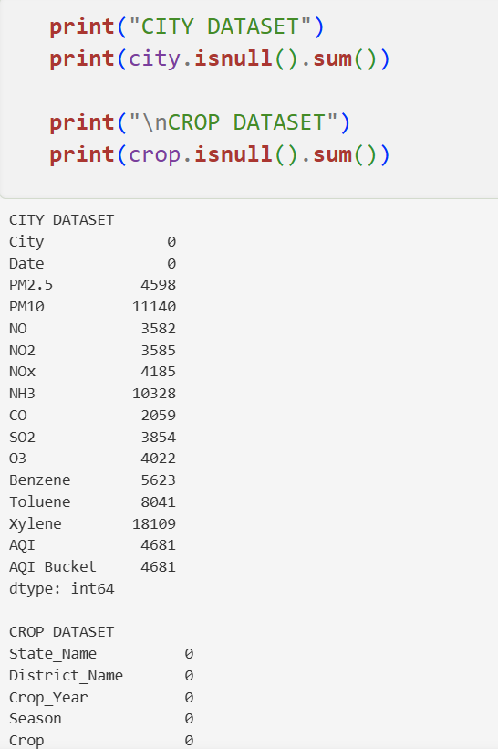
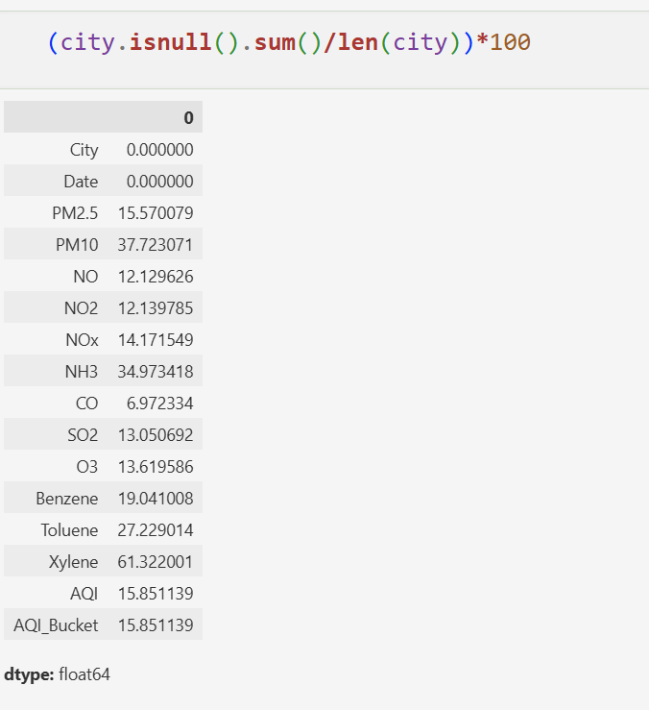
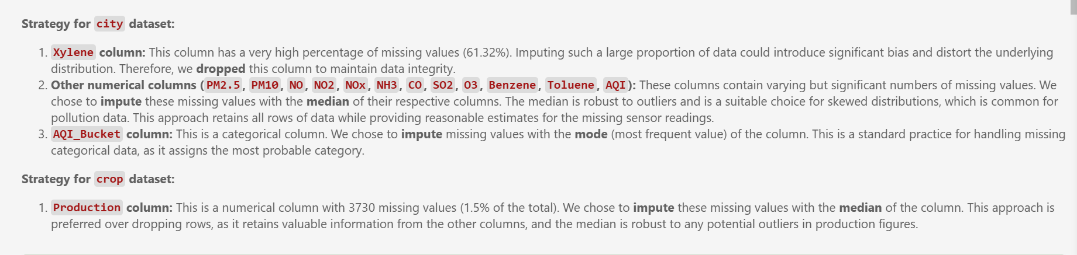
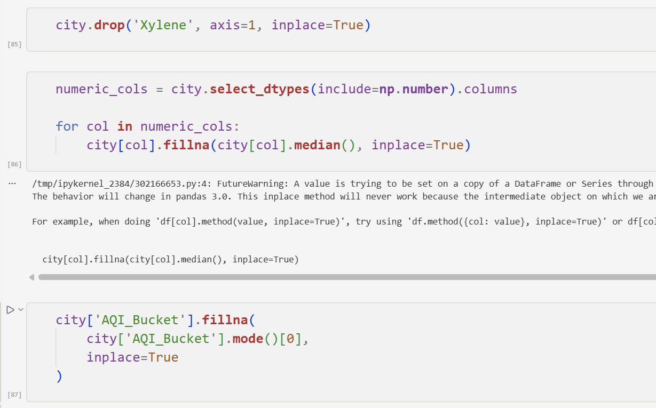
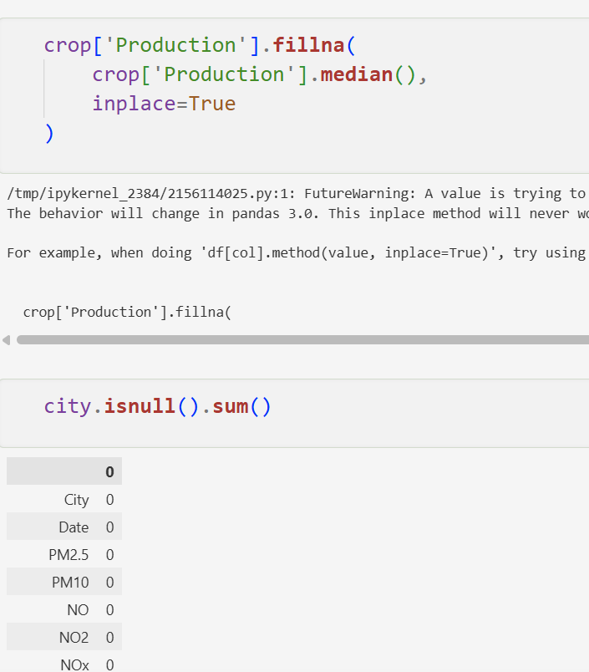
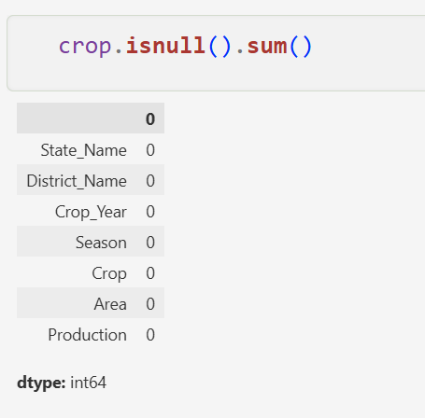

Task 3 The two files disagree on how to spell "Tamil Nadu"

You need to combine both files later in the lab using the State column as the common key. But when you look closely, the same state appears with different spellings, extra spaces, or old names across the two files. There are also rows that appear more than once for no clear reason.
Make both files agree on state names and remove any redundant records. Document every inconsistency you found and how you resolved it. Show that the files are now ready to be merged reliably.

A list of all inconsistencies found and the fix applied for each
Record counts before and after to prove duplicates were removed
Think: What could go wrong in a merge if state names don't match exactly? How would you systematically find all variants of a state name? 2 marks
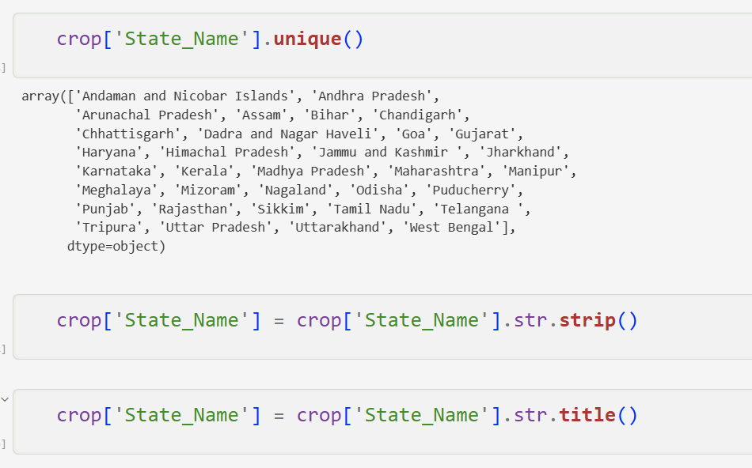
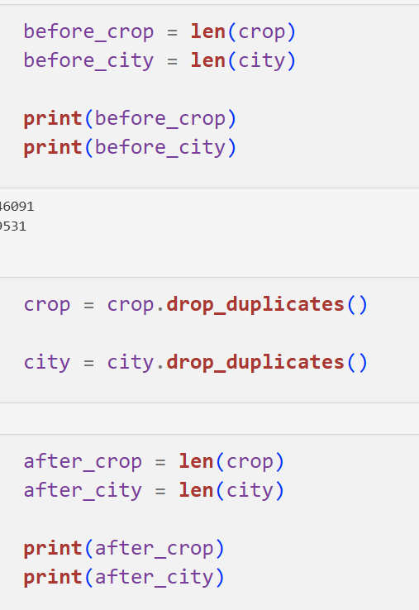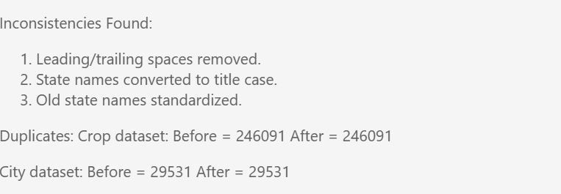
Task 4
Where do most cities actually sit on the AQI scale?

The pollution control board wants to know — are most Indian cities moderately polluted, or is the problem concentrated in just a few places? They also want to know whether the average AQI is a fair number to report publicly, or whether extreme cities are pulling it up unfairly.

Investigate the shape of the AQI distribution. Decide which visualisation(s) best answer both questions the board is asking, justify your choice, produce the plot(s), and record two specific observations that directly address their concerns.

Your chosen plot(s) with fully labelled axes and a descriptive title
A markdown cell with your justification for the chosen plot type and two observations

Think: Which plot shows where values cluster? Which one reveals extreme values? Do you need one plot or two to answer both questions? 2 marks

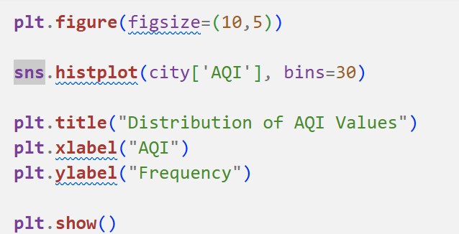
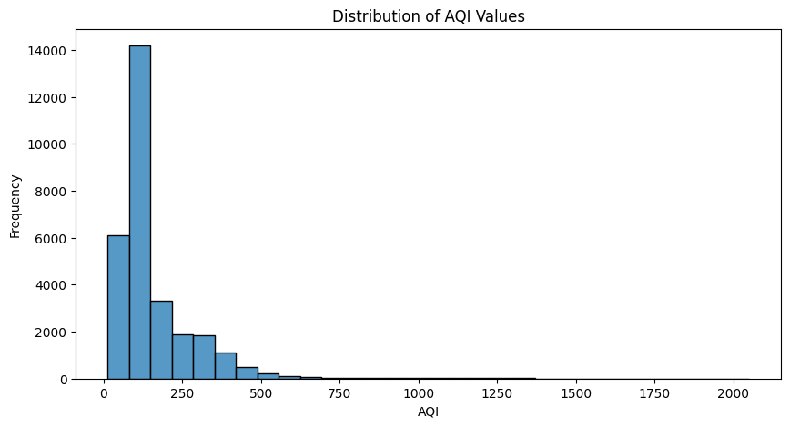
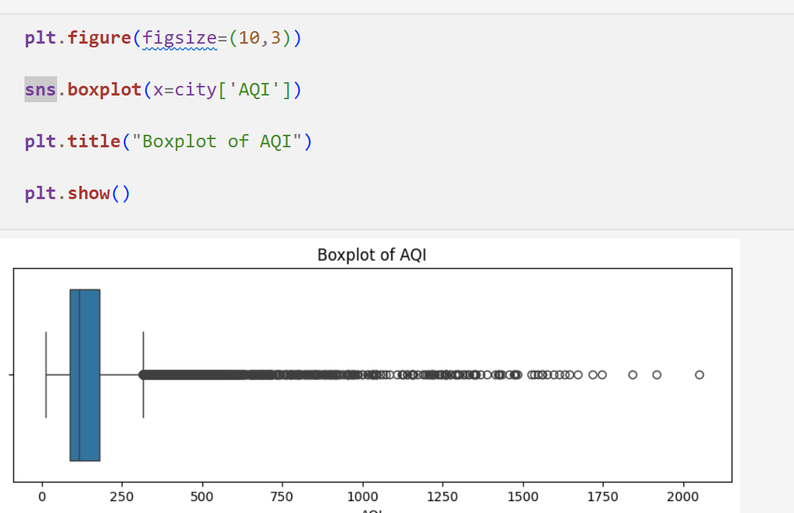
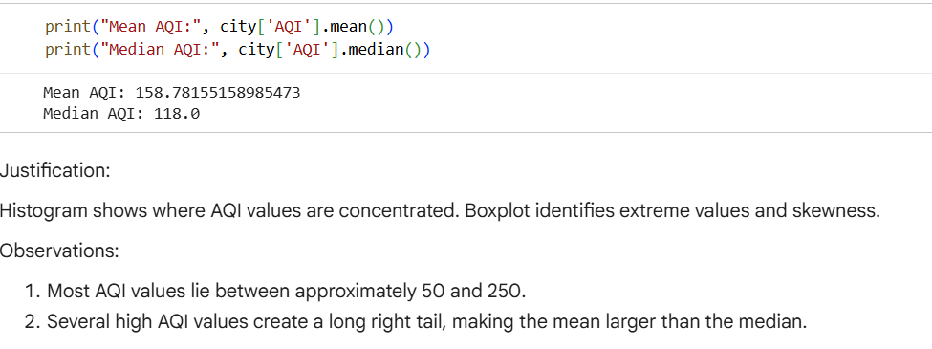

Task 5
Something is making the average AQI look worse than it is

A data quality report flags that a few AQI readings in the dataset are implausibly high — values that no monitoring station should realistically record. If left in, these values will distort every statistic and model built on this data. The team lead asks you to "handle the extreme values properly" but does not tell you how.
Identify whether extreme values exist, quantify them, decide on an appropriate treatment method, apply it, and demonstrate that the data is now cleaner. Justify every decision you make.

The method you chose to detect extremes and why
The count of values affected and the treatment applied
A visual comparison of the data before and after treatment
Think: Should extreme values always be deleted? What are the alternatives? How do you prove your treatment actually worked? 2 marks
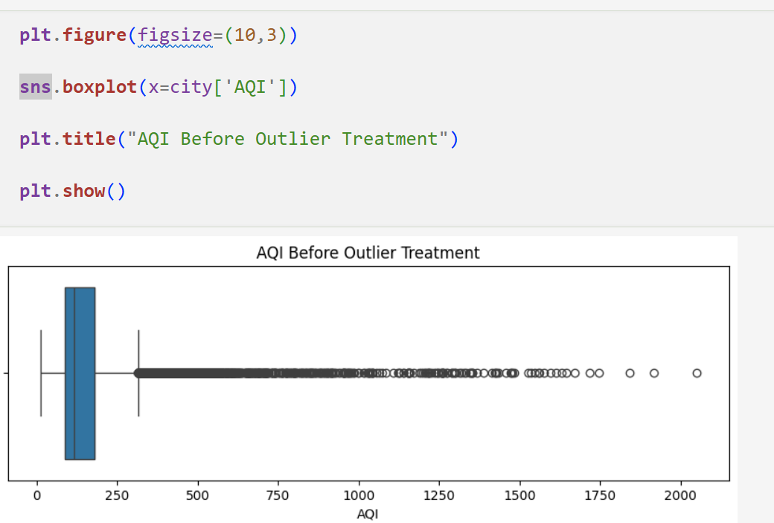
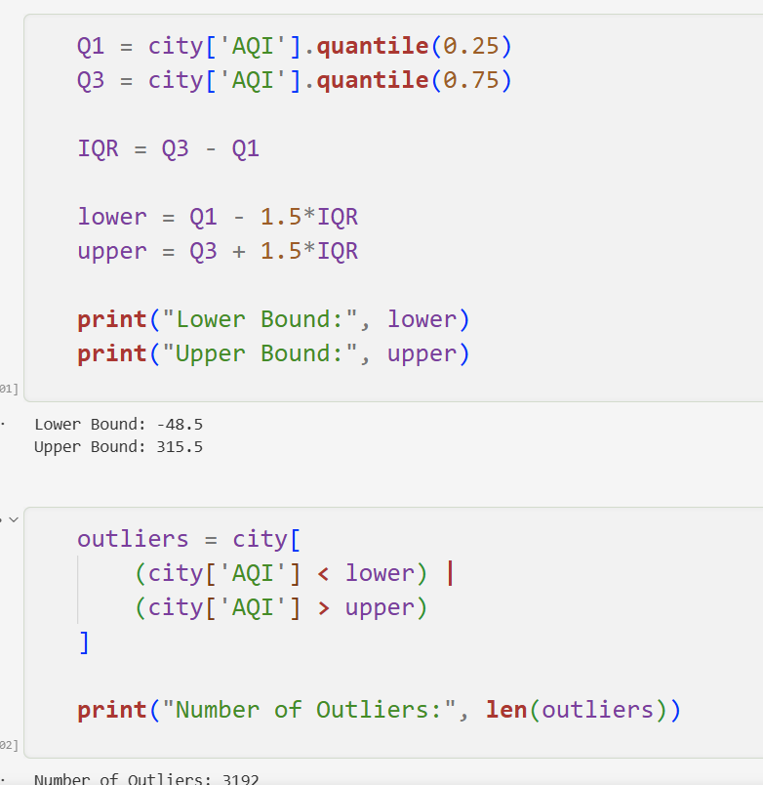
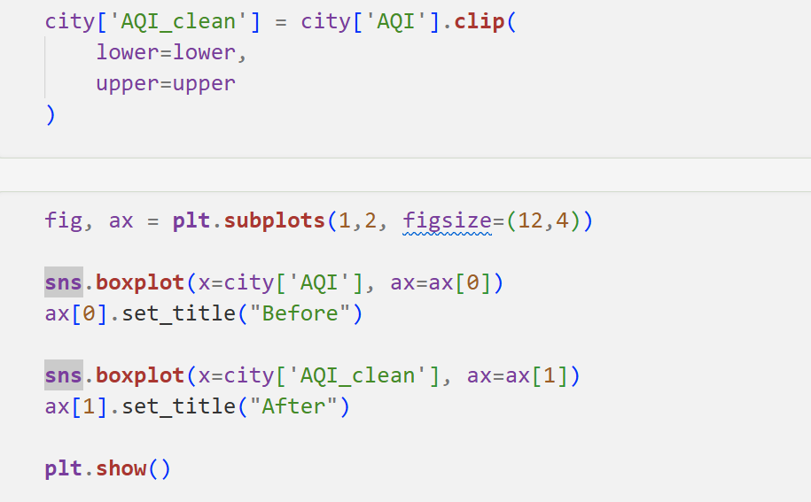
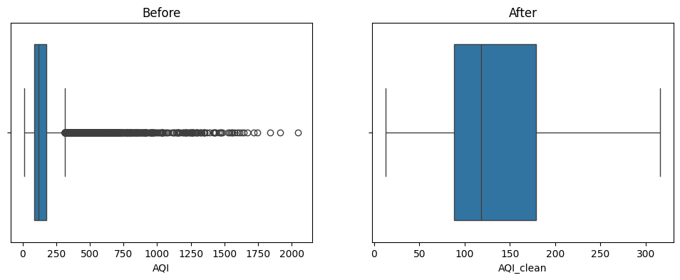
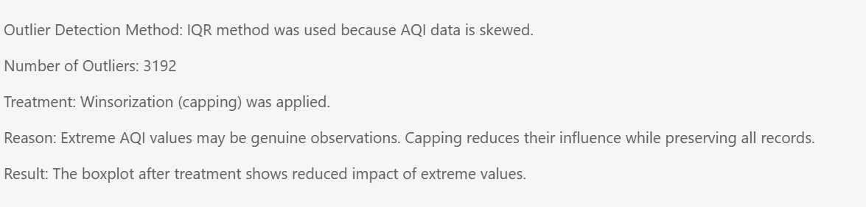

Conclusion /inference

Lab 2

Lab Exercise 2:

Aim
- To investigate whether worsening air quality across Indian states is linked to declining agricultural output by independently choosing, applying, and justifying appropriate data analysis and visualisation techniques on raw, messy, real-world datasets.

Evaluation Rubrics

Submission Guidelines
- Make a copy of the lab manual template with your <name_reg:no_subject name>
- Copy the given question and the answer (lab code) with results, followed by the conclusion of that lab. Title the lab as Lab 1.
- Keep updating your lab manual and show the lab manual of that particular lab for evaluation.
- Create a Git repository in your profile <ML lab-reg no>. Follow a different branch for each lab <Lab 1, Lab 2 …> and push the code to Git.
- Provide the Git link in Google Classroom along with the PDF of the lab manual.
- Upload the PDF to Google Classroom before the deadline.

Code with Results
ask 6: Is India's air getting better or worse over time?

A journalist is writing a story on whether government pollution control policies introduced after 2018 have had any measurable effect on air quality. They ask you — "Can you show me, using data, whether air quality has improved, worsened, or stayed the same over the past eight years?"

Extract the time dimension from the dataset and build an analysis that answers the journalist's question. Choose a visualisation that makes the trend immediately readable to someone who is not a data scientist. Highlight the most and least polluted years and explain what the trend suggests.

Your plot with the trend clearly visible and key years highlighted
A markdown response to the journalist's question — one paragraph, plain language

Think: What needs to happen to the Date column before you can group by year? Which plot type communicates a trend over time most clearly? 2 marks

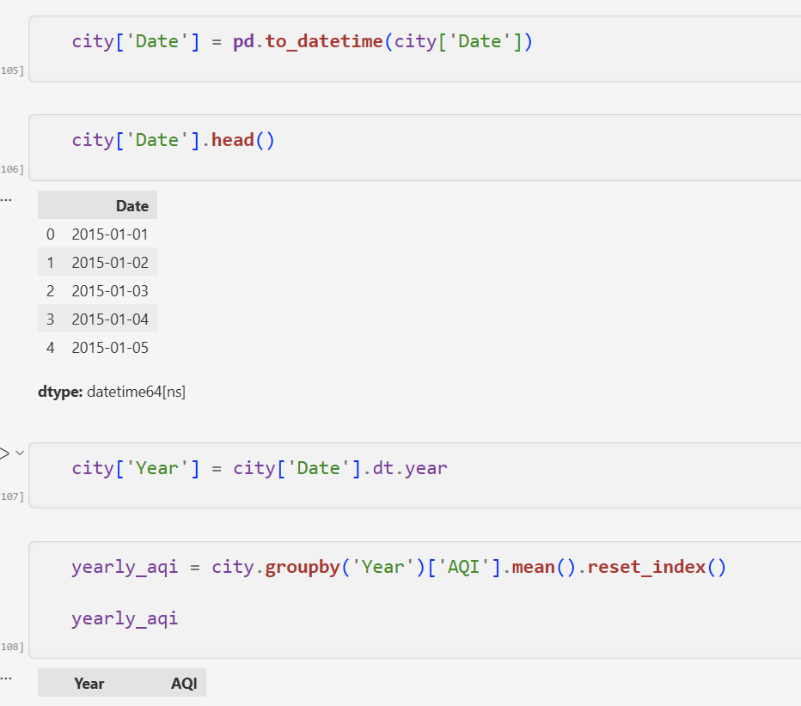
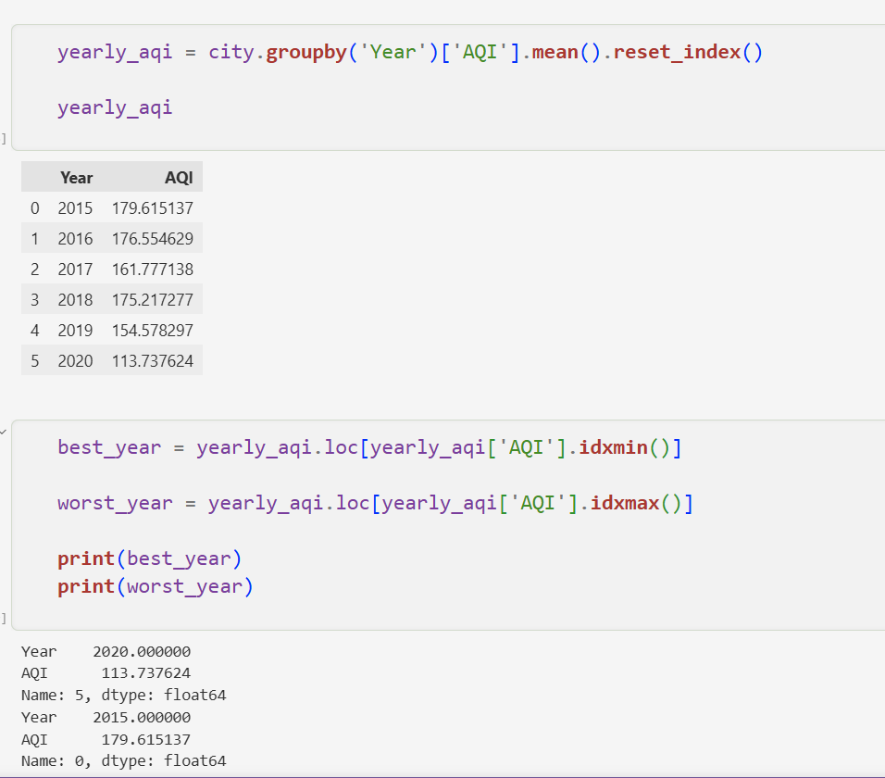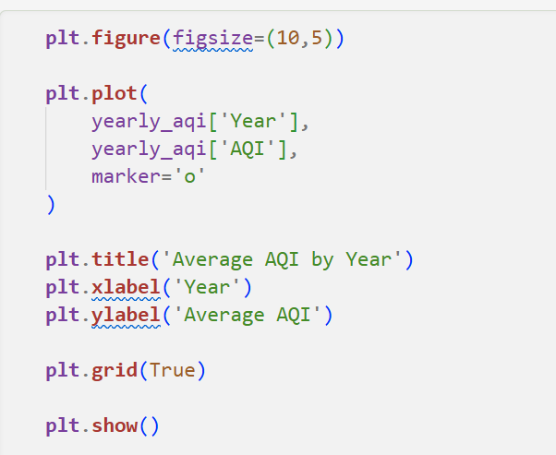
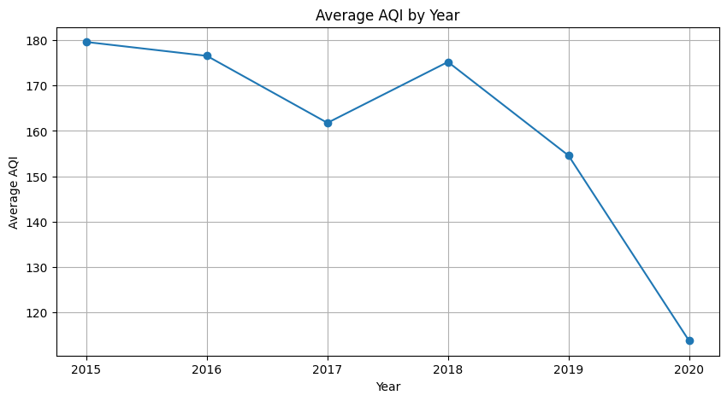

Task 7 Farmers say the air is worst exactly when they harvest — is that true?

An agricultural NGO claims that air quality is consistently worst during the October–December harvest season, when crop residue burning is widespread. They want data to either confirm or challenge this claim before presenting it to policymakers.
Investigate whether AQI follows a seasonal pattern across the year. Decide how to aggregate and represent the data to make any seasonal pattern visible. Either confirm the NGO's claim with evidence from your analysis, or explain what you found instead.

A visualisation that clearly shows how AQI varies across months or seasons
A markdown cell that directly responds to the NGO's claim with data evidence

Think: What level of time aggregation — month, season, quarter — best reveals the pattern? How do you extract that from a date column? 2 marks
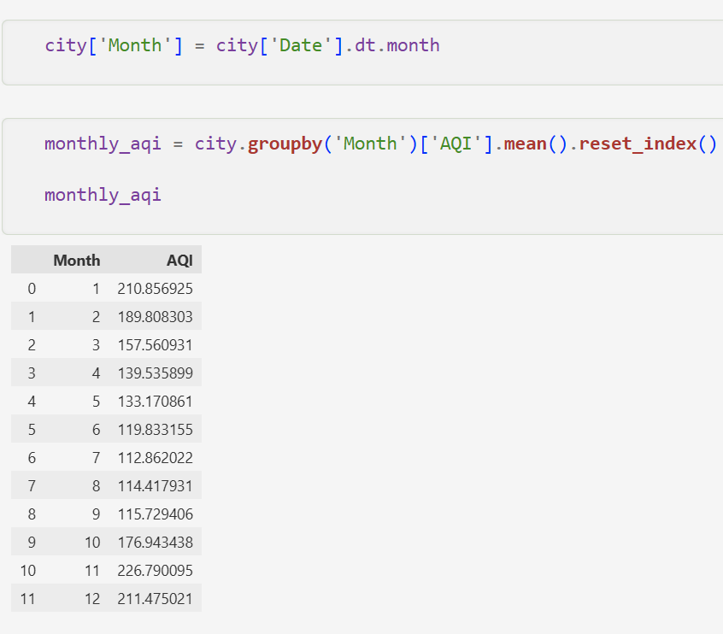
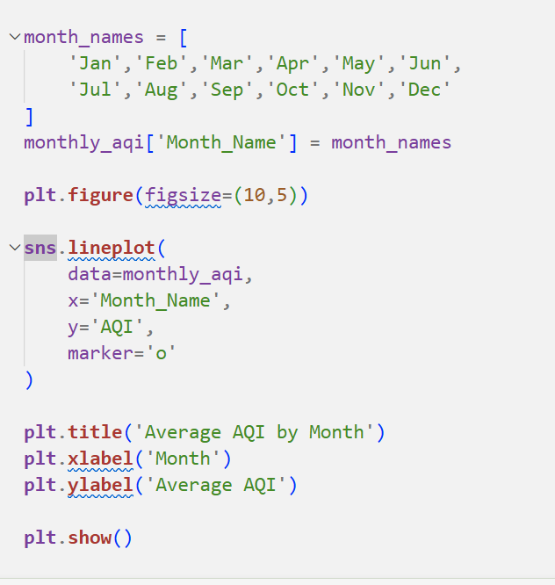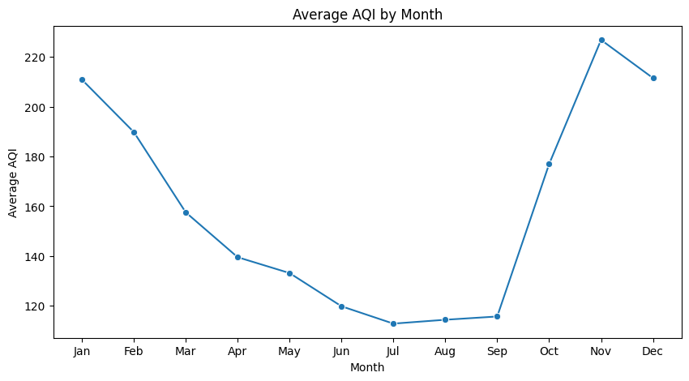

Task 8: Can the two datasets talk to each other?

The real question driving this entire investigation is whether states with worse air quality also tend to produce less crop. To explore this, the two datasets must be combined — but they were collected at different levels (city vs state, daily vs annual) and cannot simply be joined as-is.
Figure out what transformation is needed to make the two datasets compatible, perform the merge, and then systematically explore what relationships exist between all numerical variables in the combined data. Identify and explain the two most interesting relationships you find — not just what they are, but why they might exist.

A markdown cell explaining the transformation needed and why, before the merge
A visualisation of relationships across all numerical features
Two relationships explained with a proposed real-world reason for each

Think: If one file has city-day rows and the other has state-year rows, what needs to happen before they can be joined? What does a correlation matrix actually tell you — and what doesn't it tell you? 3 marks
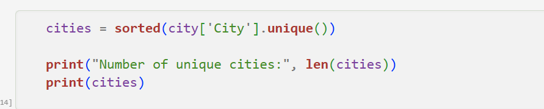
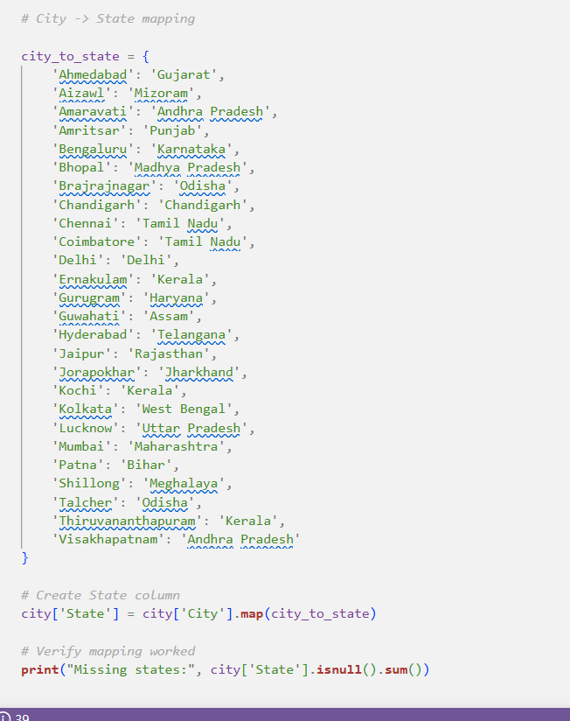
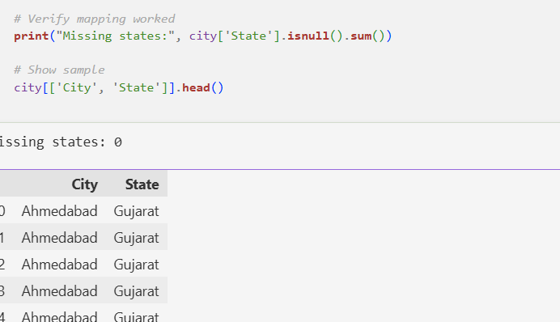
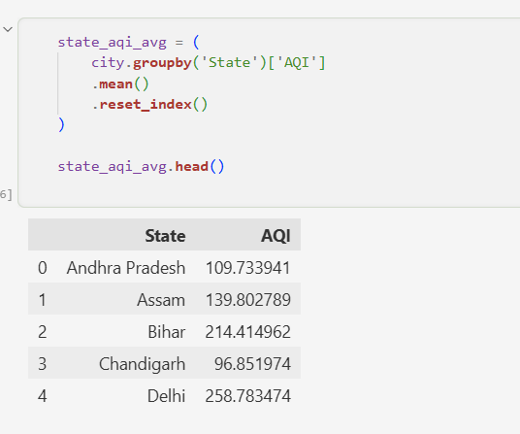
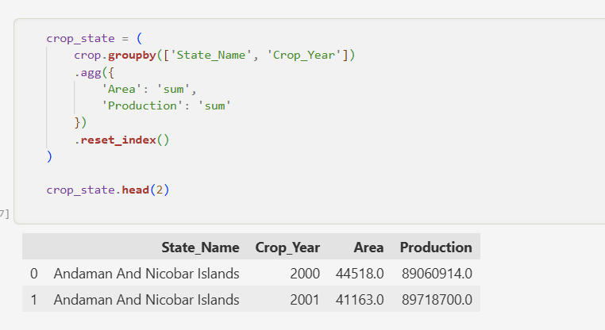
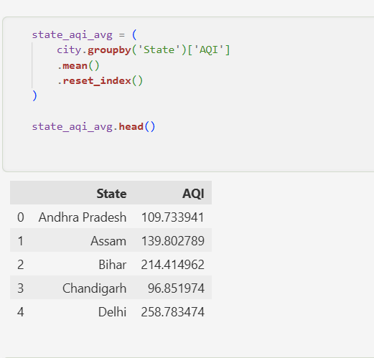
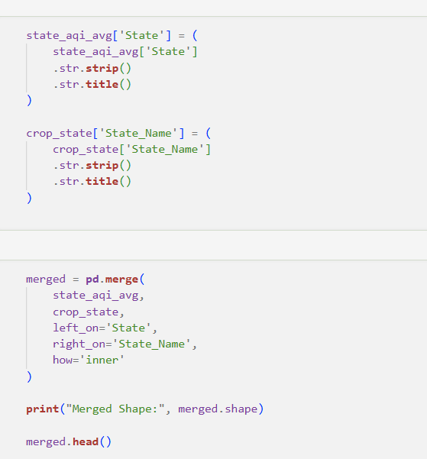
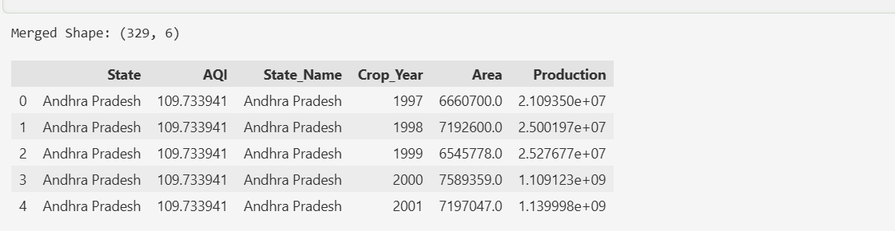
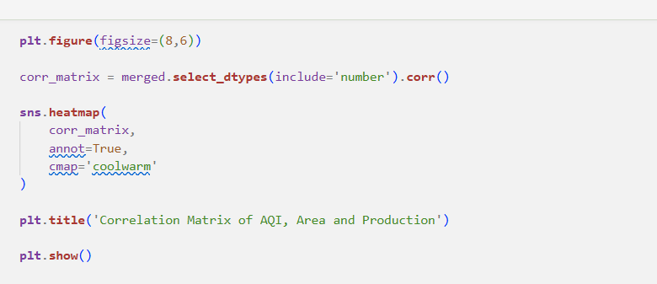
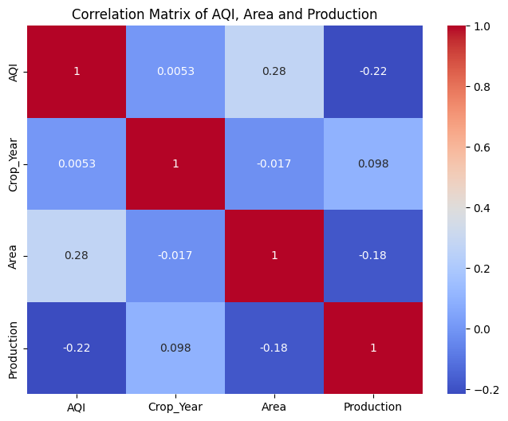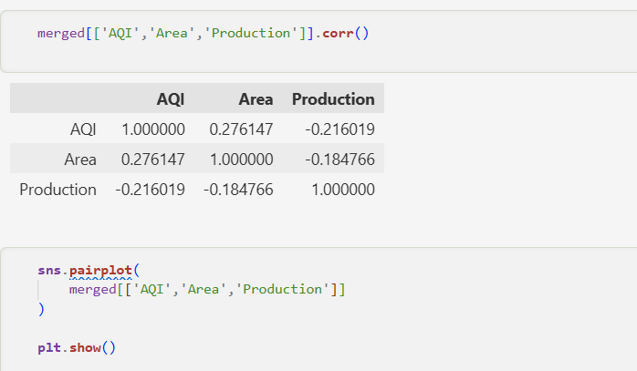
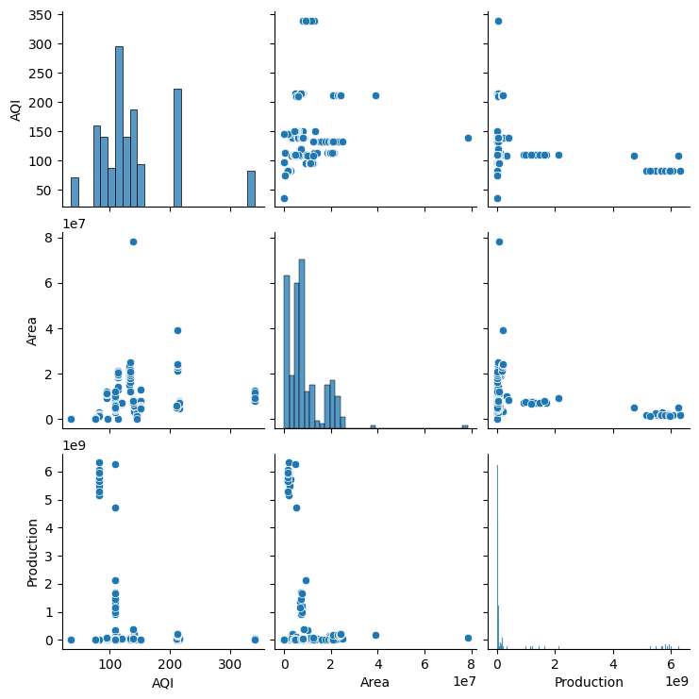

Task 9 : The minister needs to act — what do you tell her?

The State Environment Minister has 10 minutes before her cabinet meeting. She has never opened a Jupyter notebook. Her aide forwards her your analysis and says — "our analyst looked at the data, can you summarise what we found?" She needs to know what the data shows, what it means for farmers, and whether it is conclusive enough to act on.

Write a clear, honest briefing addressed directly to the minister. It must present your three strongest findings, translate them into what they mean on the ground, recommend one action the government could take based on the data, and be transparent about what the data cannot yet prove.

150–200 words in a markdown cell, addressed to the minister. Three findings, one recommendation, and one honest limitation Zero jargon — if a term needs explaining, replace it with plain language
Think: Which of your findings actually matters to a farmer or a policymaker? What is the difference between correlation and proof? Would the minister act on what you found? 3 marks
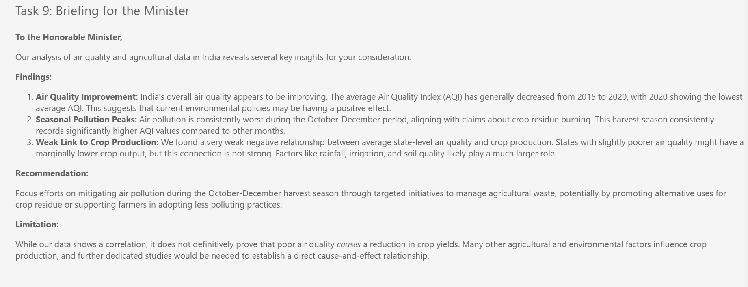
Extra part A:-
